**1.Data Set Used:**

sales_order_data.csv

**2.creating Hbase table:**

create 'sales_order_data_table','ORDER','SALES','PRODUCT','ADDRESS','CONTACT'

**3.Creating External Hive table:**

CREATE external TABLE IF not exists hbase_sales_order_data(

key string,

QUANTITYORDERED int,

PRICEEACH float,

ORDERLINENUMBER int,

SALES float,

STATUS string,

QTR_ID int,

MONTH_ID int,

YEAR_ID int,

PRODUCTLINE string,

MSRP int,

PRODUCTCODE string,

PHONE string,

CITY string,

STATE string,

POSTALCODE string,

COUNTRY string,

TERRITORY string,

CONTACTLASTNAME string,

CONTACTFIRSTNAME string,

DEALSIZE string)

ROW FORMAT DELIMITED

FIELDS TERMINATED BY ','

STORED BY 'org.apache.hadoop.hive.hbase.HBaseStorageHandler'

WITH SERDEPROPERTIES

("hbase.columns.mapping"=":key,ORDER:QUANTITYORDERED,ORDER:PRICEEACH,ORDER:ORDERLINENUMBER,SALES:SALES,SALES:STATUS,

SALES:QTR_ID,SALES:MONTH_ID,SALES:YEAR_ID,PRODUCT:PRODUCTLINE,PRODUCT:MSRP,PRODUCT:PRODUCTCODE,ADDRESS:PHONE,ADDRESS:CITY,ADDRESS:STATE,ADDRESS:POSTALCODE,

ADDRESS:COUNTRY,ADDRESS:TERRITORY,CONTACT:CONTACTLASTNAME,CONTACT:CONTACTFIRSTNAME,CONTACT:DEALSIZE")

TBLPROPERTIES("hbase.table.name"="sales_order_data_table")

;

**4.Creating Hive external staging table:**

CREATE external TABLE IF not exists hbase_sales_order_data_staging(

key string,

QUANTITYORDERED int,

PRICEEACH float,

ORDERLINENUMBER int,

SALES float,

STATUS string,

QTR_ID int,

MONTH_ID int,

YEAR_ID int,

PRODUCTLINE string,

MSRP int,

PRODUCTCODE string,

PHONE string,

CITY string,

STATE string,

POSTALCODE string,

COUNTRY string,

TERRITORY string,

CONTACTLASTNAME string,

CONTACTFIRSTNAME string,

DEALSIZE string)

ROW FORMAT DELIMITED

FIELDS TERMINATED BY ','

tblproperties("skip.header.line.count" = "1")

;

**5. Loading the data into a stage table:**

Load data local inpath '/usr/tmp/sales_order_data.csv' into table hbase_sales_order_data_staging;

**6. Insert the data from stage table to main hive table:**

insert into table hbase_sales_order_data select * from hbase_sales_order_data_staging;

**7. Put the data into the hbase table:**

put 'sales_order_data_table' , '1', 'ORDER:QUANTITYORDERED', '11'

put 'sales_order_data_table' , '1', 'ORDER:PRICEEACH', '2000'

put 'sales_order_data_table' , '1', 'ORDER:ORDERLINENUMBER', '7'

put 'sales_order_data_table' , '1', 'SALES:SALES', '1234'

put 'sales_order_data_table' , '1', 'SALES:STATUS', 'In Process'

put 'sales_order_data_table' , '1', 'SALES:QTR_ID', '4'

put 'sales_order_data_table' , '1', 'SALES:MONTH_ID', '6'

put 'sales_order_data_table' , '1', 'SALES:YEAR_ID', '2008'

put 'sales_order_data_table' , '1', 'PRODUCT:PRODUCTLINE','Trucks'

put 'sales_order_data_table' , '1', 'PRODUCT:MSRP','200'

put 'sales_order_data_table' , '1', 'PRODUCT:PRODUCTCODE','S50_1392'

put 'sales_order_data_table' , '1', 'ADDRESS:phone','40.67.8555'

put 'sales_order_data_table' , '1', 'ADDRESS:CITY','Banglore'

put 'sales_order_data_table' , '1', 'ADDRESS:STATE','UP'

put 'sales_order_data_table' , '1', 'ADDRESS:POSTALCODE','201551'

put 'sales_order_data_table' , '1', 'ADDRESS:COUNTRY','FRANCE'

put 'sales_order_data_table' , '1', 'ADDRESS:TERRITORY','EMEA'

put 'sales_order_data_table' , '1', 'CONTACT:CONTACTLASTNAME','Labrune'

put 'sales_order_data_table' , '1', 'CONTACT:CONTACTFIRSTNAME','Janine'

put 'sales_order_data_table' , '1', 'CONTACT:DEALSIZE','Small'

**8.Data in Hbase after putting the data using put command:**

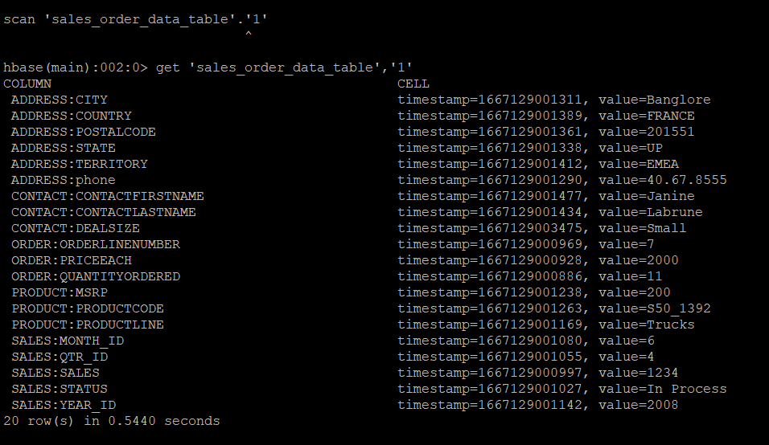

**9.Data in Hive after putting data in Hbase:**

